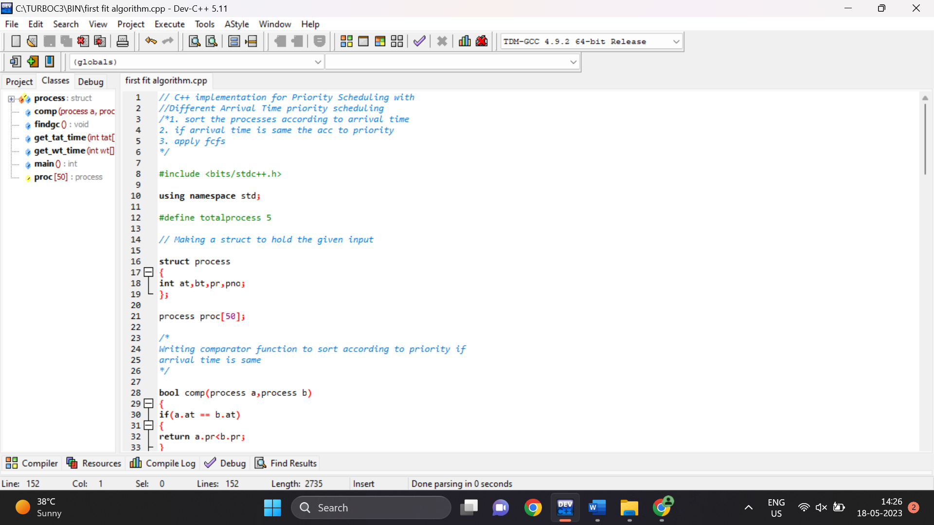

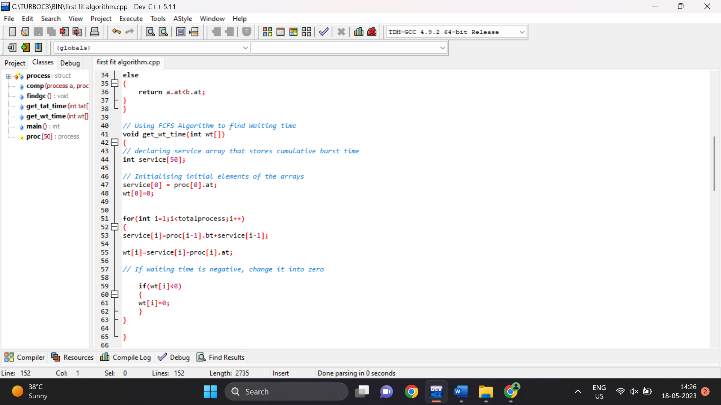

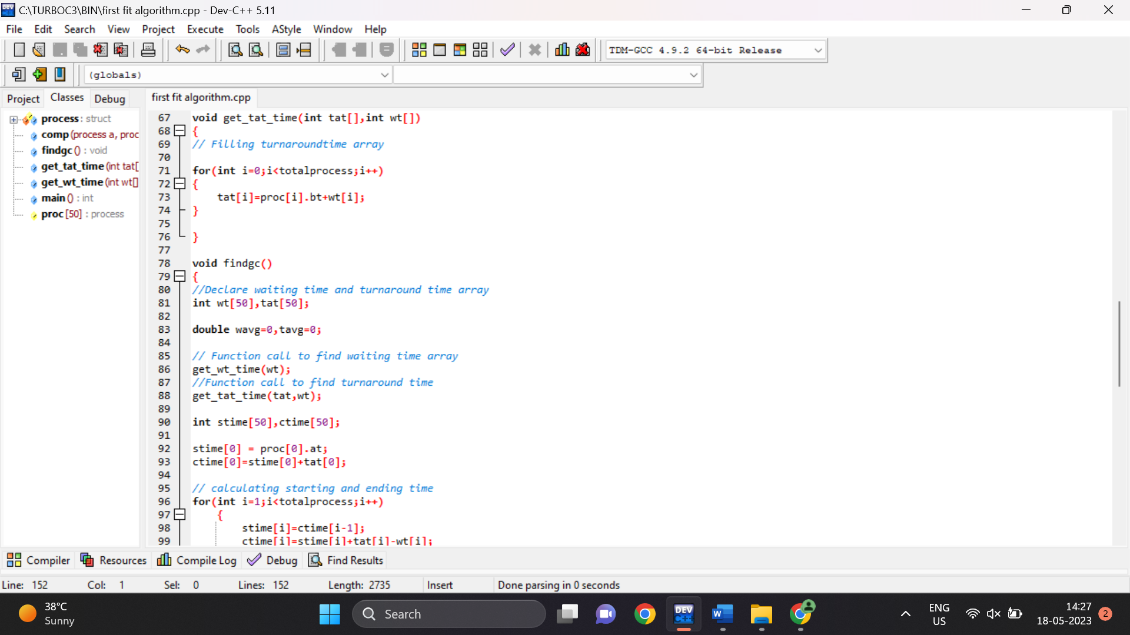

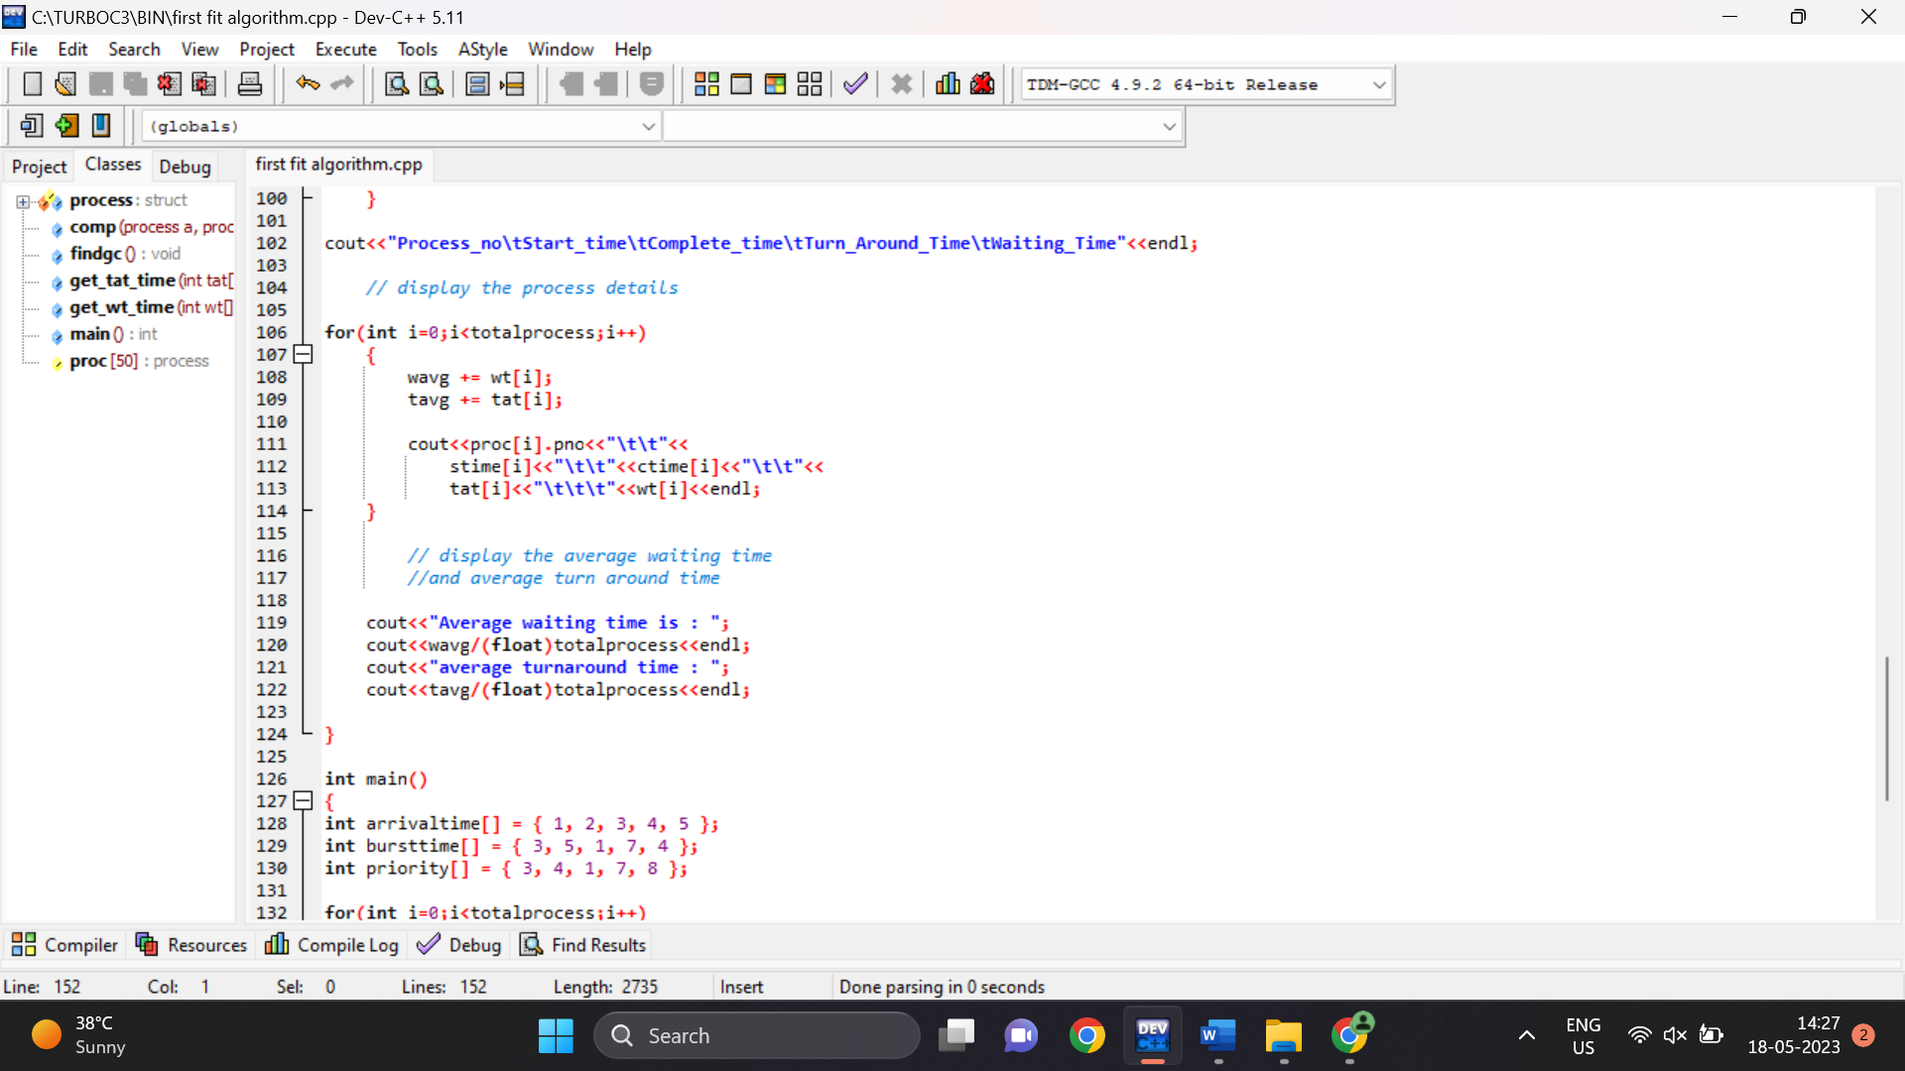

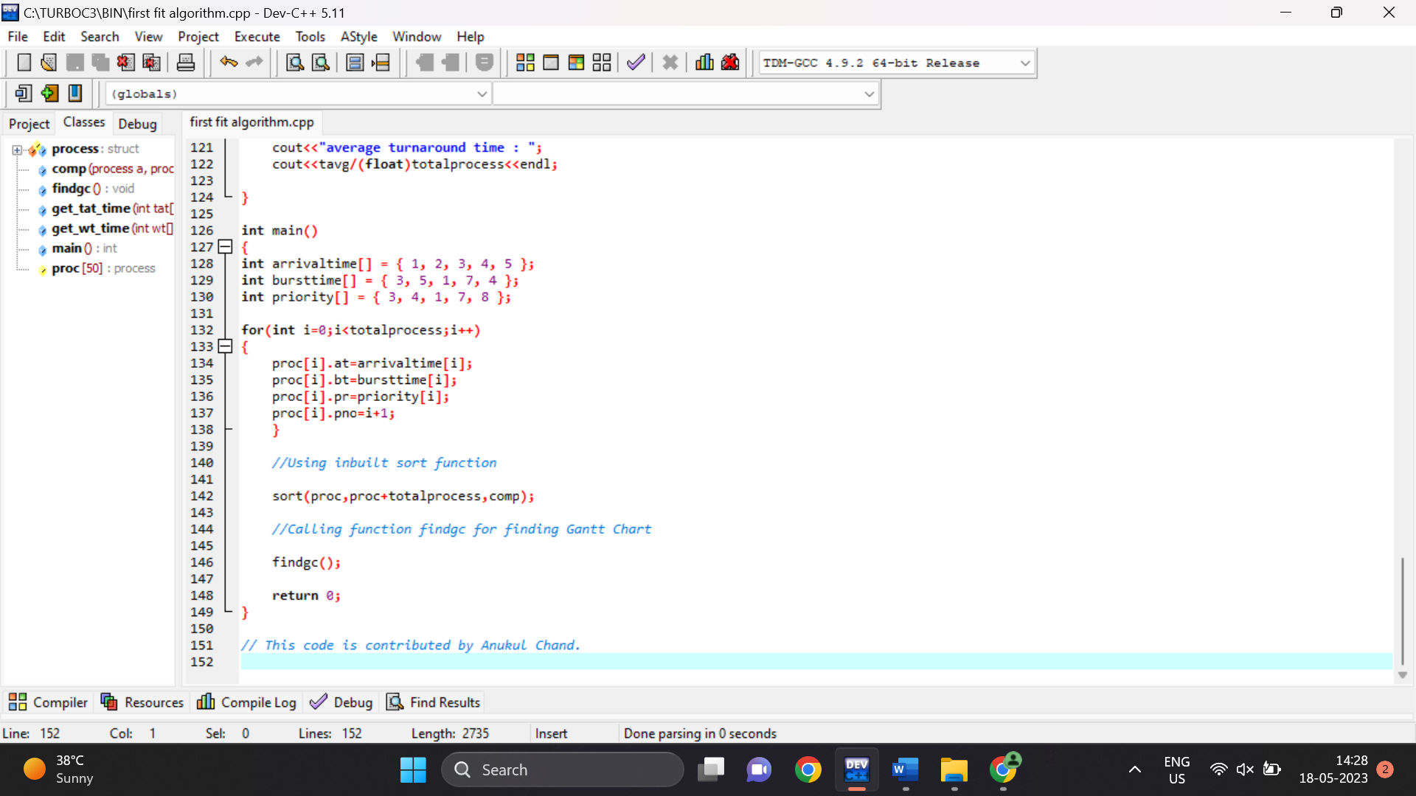

Output:

Process_no Start_time Complete_time Turn_Around_Time Waiting_Time

1 1 4 3 0

2 4 9 7 2

3 9 10 7 6

4 10 17 13 6

5 17 21 16 12

Average waiting time is : 5.2

average turnaround time : 9.2

--------------------------------

Process exited after 0.06529 seconds with return value 0

Press any key to continue . . .